Semi-annual Environmental Monitoring Report

Project Number: KGZ 49240 July - December 2021

Kyrgyz Republic: Uch Kurgan Hydropower Plant Modernization Project
(Financed by the Loan 3778-KGZ (COL)/Grant 0643-KGZ (SF))

Prepared by the Open Joint Stock Company Electric Power Plants for the Asian Development Bank.

This environmental monitoring report is a document of the borrower. The views expressed herein do not necessarily represent those of ADB's Board of Directors, Management, or staff, and may be preliminary in nature.

In preparing any country program or strategy, financing any project, or by making any designation of or reference to a particular territory or geographic area in this document, the Asian Development Bank does not intend to make any judgments as to the legal or other status of any territory or area.

Table of Contents

- INTRODUCTION 5
  - Preamble 5
  - Headline Information 5
- PROJECT DESCRIPTION AND CURRENT ACTIVITIES 9
  - Project Description 9
  - Project Contracts and Management 10
  - Project Activities During Current Reporting Period 12
  - Description of Any Changes to Project Design 12
  - Description of Any Changes to Agreed Construction methods 12
- ENVIRONMENTAL SAFEGUARD ACTIVITIES 13
  - General Description of Environmental Safeguard Activities 13
  - Site Audits 13
  - Issues Tracking (Based on Non-Conformance Notices) 13
  - Trends 13
  - Unanticipated Environmental Impacts or Risks 13
- RESULTS OF ENVIRONMENTAL MONITORING 14
  - Overview of Monitoring Conducted during Current Period 14
  - Trends 14
  - Summary of Monitoring Outcomes 14
  - Material Resources Utilisation 14
    - Current Period 14
    - Cumulative Resource Utilisation 14
  - Waste Management 14
    - Current Period 14
    - Cumulative Waste Generation 14
  - Health and Safety 14
    - Community Health and Safety 14
    - Worker Safety and Health 14
  - Training 15
- FUNCTIONING OF THE SEMP 16
  - SEMP Review 16
- GOOD PRACTICE AND OPPORTUNITY FOR IMPROVEMENT 17
  - Good Practice 17
  - Opportunities for Improvement 17
- SUMMARY AND RECOMMENDATIONS 18
  - Summary 18
  - Recommendations 18

LIST OF PICTURES
Picture 1. Uch Kurgan Hydropower Plant 7

LIST OF SCHEMES
Scheme 1. Environmental management of the Uch Kurgan HPP Modernization Project 9

LIST OF ANNEXES:
Annex 1. Conclusion of the State environmental expert review on IEE developed for the Uch- Kurgan Modernization Project 16

Abbreviations
ADB | Asian Development Bank
CC | Construction Contractor
EMP | Environmental Management Plan
EPP/OJSC EPP | Open Joint Stock Company Electric Power Plant Company
ES | Environmental Specialist
HPP | Hydro Power Plant
IEE | Initial Environmental Examination
IPID | Investment Project Implementation Department within EPP
PAM | Project Administration Manual
PIC | Project Implementation Consultant
PIU | Project Implementation Unit
SAEPF | State Agency on Environmental Protection and Forestry
SSEMP | Site Specific Environmental Management Plan

INTRODUCTION

Preamble

- This report represents the Semi - Annual Environmental Monitoring Review (SAEMR) for Uch Kurgan Hydropower Plant Modernization Project.
- This report is the fourth SA EMR for the project.

Headline Information

- The general objective of the rehabilitation works is to improve the technical and operational performances of Uch-Kurganl HPP. There are two main objectives that can be identified:
  - To recover a proper reliability and availability of the plant,

  - To increase the capacity of the power plant.

- The Initial Environmental Examination (IEE) of the Project with Environmental Management Plan (EMP) was prepared in 2018 and approved by ADB and then by the State Agency of Environmental Protection and Forestry (SAEPF) No04-8-28/488-e dated 15 October 2018 (Annex 1).
- According to IEE of the Project the anticipated impacts and corresponding mitigation measures during the construction phase of the project are:
  - Air pollution from dust emissions during rehabilitation, movement of earth materials and emission from movement of heavy equipment and construction vehicles. This will be mitigated by good construction practices such as water spraying on road surface and work areas, covering all materials during transportation, and proper maintenance of construction vehicles and equipment;
  - Water pollution accidental spillage of oil and other lubricants from construction equipment and increased turbidity during dredging works. The potential spillages will be mitigated by timely removal of the polluted soil and checking of the construction machines for leaks. Turbidity will be controlled with the use of silt screens and special cutter dredger heads to minimize and reduce turbidity levels which will be duly monitored;

  - Noise pollution from construction activities that causes a nuisance to local communities will be mitigated through consultation with communities regarding the schedule and time of noise-generating construction activities, and the use of noise limitation techniques on construction equipment;
  - The generation of construction wastes, which will be mitigated by the provision of waste bins in construction sites and the proper segregation, collection and disposal of solid wastes; oils and scrap metals will be kept safe at the on-site storage area, which will be improved with financing under the project. EPP is responsible for ensuring that licensed companies, under the monitoring and supervision of the PIC and PIU, recycle and dispose oils and scrap metals.
  - Sediments excavation from dredging works will be managed according to two scenarios (sediments are dangerous or not) in compliance with applicable environmental standards; although first round of surface sampling and analysis found no contaminants, samples will be collected at various depths to check if contaminants are present in deeper layers. The sampling and testing will be completed before any dredging operation could start.
  - Occupational health and safety in construction sites, potentially causing harm and danger to the lives and welfare of workers. This will be mitigated through the implementation of an environment, health and safety plan, including the provision of personal protective equipment to all workers; and
  - Community health and safety, such as the anxiety of the population by the movement of heavy trucks on the public roads. This will be mitigated through implementation of a traffic plan agreed by the local authorities.
- According to ADB Safeguard Policy Statement, the Project has been classified as Category B.
- The Uch-Kurgan Modernization Project consists of following packages:

  - Package 1 - Dredging equipment and related services

  - Package 2 - HPP electromechanical generation equipment and hydraulic steel structure replacement
- Tender for Package 1 - Dredging equipment and related services is not announced yet.

- Unincorporated joint venture composed of EDF Société Anonyme (France), Egis Eau and Egis International (France) represented by EDF SA as leading member was awarded a contract on 31 March 2021 for supervision services to implement successfully the rehabilitation works of Uch-Kurgan Modernization Project as PIC.
- The Contract for Package 2 - HPP electromechanical generation equipment and hydraulic steel structure replacement has been awarded to the Consortium of China National Electric Engineering Co., Ltd. and Dongfang Electric Machinery Co., Ltd. and the Contract Agreement was signed by Electric Power Plants (EPP) and the Contractor on 14 June 2021. The Contract effective date is September 23, 2021. Works of Package 2 include the rehabilitation and replacement of these components:
  - Turbines
  - Turbine governor systems
  - Low pressure compressed air system
  - Cooling water system
  - Drainage and dewatering systems
  - Oil infrastructure system
  - Ventilation and air conditioning systems
  - Sewage water system
  - Powerhouse travelling crane
  - Generators
  - Excitation systems
  - Generator fire fighting system
  - Generator neutral grounding system
  - Main step-up power transformers
  - Unit control system
  - Unit condition monitoring
  - Electrical protection system
  - Station control system and SCADA
  - Plant fire fighting system
  - Plant lighting system
  - Auxiliary transformers
  - 380 VAC power distribution system
  - DC system and UPS
  - Isolated and segregated phase busducts

  - Generator circuit breakers
  - 10.5 kV switchboards
  - 110 kV HV switchyard
  - Diesel generator set
  - Hydraulic steel structures – Gates and auxiliaries
  - Hydraulic steel structures – Gantry cranes
- The Contractor for Package 2 has started the surveying work and data collection for designing.

PROJECT DESCRIPTION AND CURRENT ACTIVITIES

Project Description

- Uch-Kurgan HPP is located 271 km southwest of Bishkek, close to the border to Uzbekistan. It was the first installation in the Naryn River cascade, and is mainly used to produce base load for the Kyrgyz Republic and export to Uzbekistan. Uch-Kurgan HPP includes an earth-fill dam and a concrete dam with an outdoor powerhouse of 180 MW, equipped with 4 vertical Kaplan turbines of 45 MW each (Picture 1).
- Since commercial operations started in 1962, Uch-Kurgan HPP has not had major improvements or modernization to maintain its original performance. As the plant’s condition is very poor and well past its useful economic and functional life, it needs major rehabilitation or replacement.
- The Kyrgyz Republic has received a funding from the Asian Development Bank for the Uch Kurgan HPP Modernization Project. The executing agency of this project is the Open Joint-Stock Company Electric Power Plants (EPP).
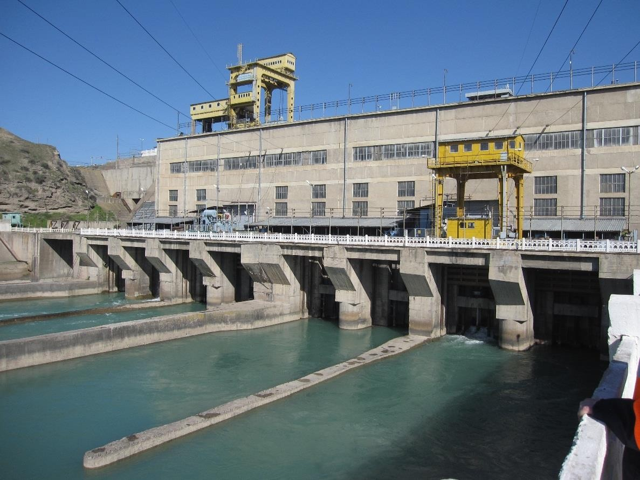
Picture 1. Uch Kurgan Hydropower Plant

Project Contracts and Management

- The objective of the executing agency, EPP is to improve the technical and operational performance of the Uch-Kurgan HPP and intends to contract the rehabilitation of the Uch-Kurgan HPP on an Engineering Procurement and Construction scheme. The Project Implementation Consultant will work with the Investment Project Implementation Department (IPID) of EPP.
- The IPID, is one of the EPP’s departments specially assigned for implementation of projects funded by international development organizations such as ADB and World Bank (WB), etc.
- Within IPID, EPP has established a dedicated Project Implementation Unit (PIU) for implementing of the Uch Kurgan HPP Modernization Project in June 2019. Head of PIU is Mr Abdusamat Nasyrov (email: piu3@es.kg). The IPID administers all consulting and procurement contracts on behalf of EPP. It is responsible for bid evaluation, contract award, construction supervision, and report to the Government and ADB.
- The IPID head Isak Khudaiberdiev reports to the Deputy General Director of EPP. The IPID is the main contact point for working communication between EPP and ADB. The IPID coordinates the consultants and contractors.
- The IPID, assisted by the PIC, submits necessary project plans, progress reports, applications for withdrawal of funds, and any other required reports to ADB and the Government.
- The Environmental expert of PIU EPP Uch Kurgan HPP Modernization Project will be hired until the 1st of March 2022. By the deadline for submitting a CVs on September 2, 2021, for the position of Environmental expert, there was not a single applicant. Due to the absence of participants in this tender, we were forced to revise the requirements of the Terms of Reference and announce a re-selection already in early December 2021.
- PIC of EPP for Uch Kurgan HPP Modernization Project is unincorporated joint venture composed of EDF Société Anonyme (France), Egis Eau and Egis International (France) represented by EDF SA as leading member.
- The international environmental expert of PIC EDF is Mr. Farrukh Ahmad (parrukh.khan@gmail.com) and national environmental expert is Mr. Zhanybek Orozaly Uulu (bubo74@yandex.ru). The environmental experts of PIC have not been

involved yet. Since the physical works had not been started, there was no need to mobilize the environmental experts of the PIC.
- The Contractor’s environmental experts are also not involved yet because the contractor's team is not yet mobilized. Mobilization of the contractor team is expected in the first quarter of 2022.
- List of Project Contracts under implementation of the Project is Shown in Table 1.

Environmental management of the Uch Kurgan HPP Modernization Project as of June 2021 is given in Scheme 1.

Table 1: Project Contracts under the implementation of Uch Kurgan Modernization Project

Contracts | Title | Construction Contracts
D-15-31/218 dated June 14, 2021 | Package No. 2: Hydropower Electromechanical (HEM) Generation Equipment and Hydraulic Steel Structure (HSS) Replacement for Uch Kurgan HPP Rehabilitation — Design, Supply, Installation, Pre- commissioning and Commissioning | Consortium of China National Electric Engineering Co., Ltd. and Dongfang Electric Machinery Co., Ltd.

EA
OJSC Electric Power Plants, PIU,
ES: Not selected
Financing Organization
ADB
PIC
Unincorporated joint venture composed of EDF Société Anonyme (France), Egis Eau and Egis International (France)
International
ES: Farrukh Ahmad
National
ES: Mr. Zhanybek Orozaly Uulu
Construction Contractor
HSE Manager: Not selected

Scheme 1. Environmental management of the Uch Kurgan HPP Modernization Project as of June 2021

Project Activities During Current Reporting Period

- Not applicable in the reporting period.

Description of Any Changes to Project Design

- Not applicable in the reporting period.

Description of Any Changes to Agreed Construction methods

- Not applicable in the reporting period.

ENVIRONMENTAL SAFEGUARD ACTIVITIES

General Description of Environmental Safeguard Activities

- No on-site environmental safeguard activities have been applied since the construction activities have not commenced yet.

Site Audits

- No on-site audits have been applied since the construction activities have not commenced yet.

Issues Tracking (Based on Non-Conformance Notices)

- No on-site issues tracking has been applied since the construction activities have not commenced yet.

Trends

- Not applicable since the construction activities have not commenced yet.

Unanticipated Environmental Impacts or Risks

- Not applicable since the construction activities have not commenced yet.

RESULTS OF ENVIRONMENTAL MONITORING

Overview of Monitoring Conducted during Current Period

- No on-site monitoring has been applied since the construction activities have not commenced yet.

Trends

- Not applicable since the construction activities have not commenced yet.

Summary of Monitoring Outcomes

- Not applicable since the construction activities have not commenced yet.

Material Resources Utilisation

    - Current Period

- Not applicable since the construction activities have not commenced yet.

    - Cumulative Resource Utilisation

- Not applicable since the construction activities have not commenced yet.

Waste Management

- Not applicable since the construction activities have not commenced yet.

    - Current Period

- Not applicable since the construction activities have not commenced yet.

    - Cumulative Waste Generation

- Not applicable since the construction activities have not commenced yet.

Health and Safety

    - Community Health and Safety

- There were no incidents which have occurred during the reporting period which resulted in or could have resulted in Community Health and Safety issues.
    - Worker Safety and Health

- Not applicable during the reporting period.

Training

- No trainings has been conducted during the reporting period.

FUNCTIONING OF THE SEMP

SEMP Review

- Not applicable during the reporting period.

6 | GOOD PRACTICE AND OPPORTUNITY FOR IMPROVEMENT
6.1 | Good Practice
45. | Not applicable since the construction activities have not commenced yet.
6.2 | Opportunities for Improvement
46. | Not applicable during the reporting period.

7 | SUMMARY AND RECOMMENDATIONS
7.1 | Summary
47. | Not applicable during the reporting period.
7.2 | Recommendations
48. | Not applicable during the reporting period.

Annex 1. Conclusion of the State environmental expert review on IEE developed for the Uch-Kurgan Modernization Project
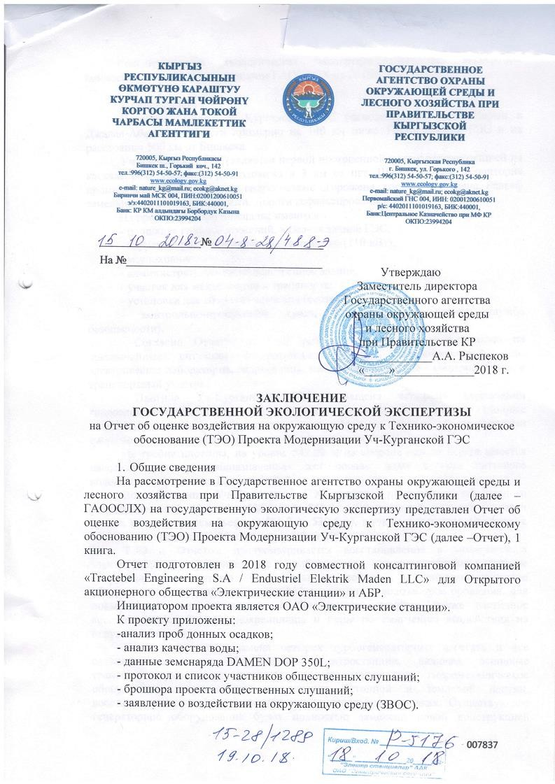

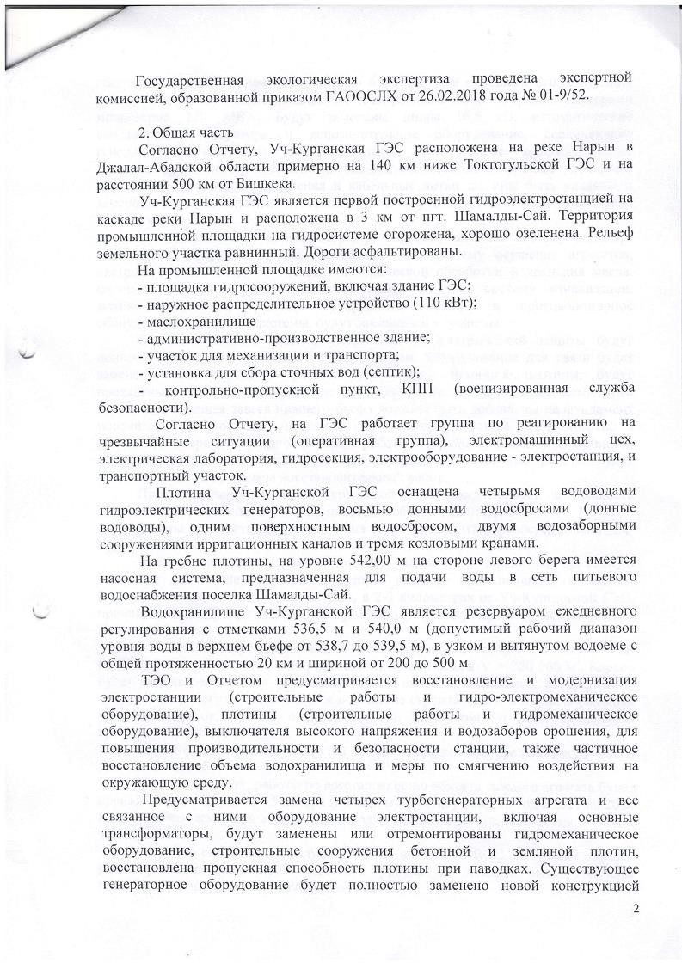

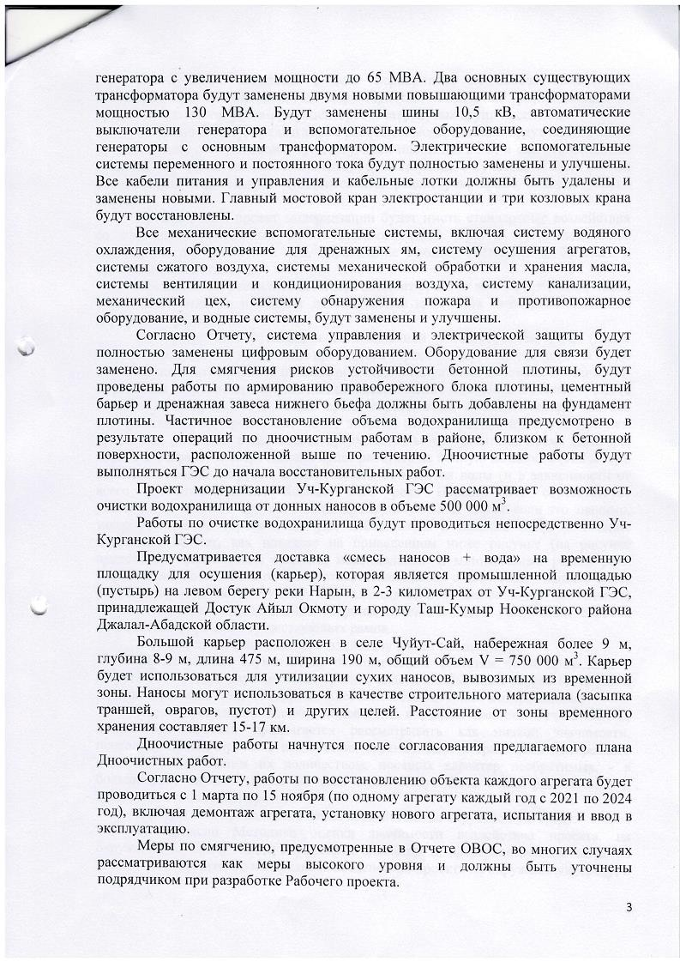

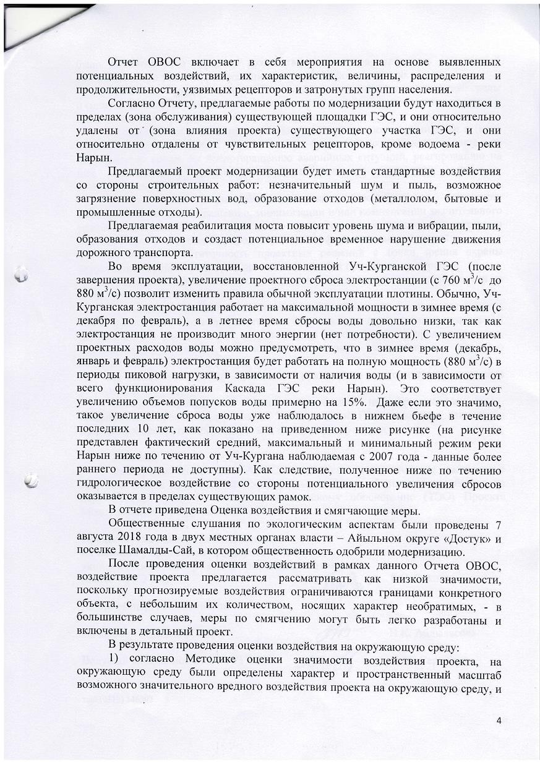

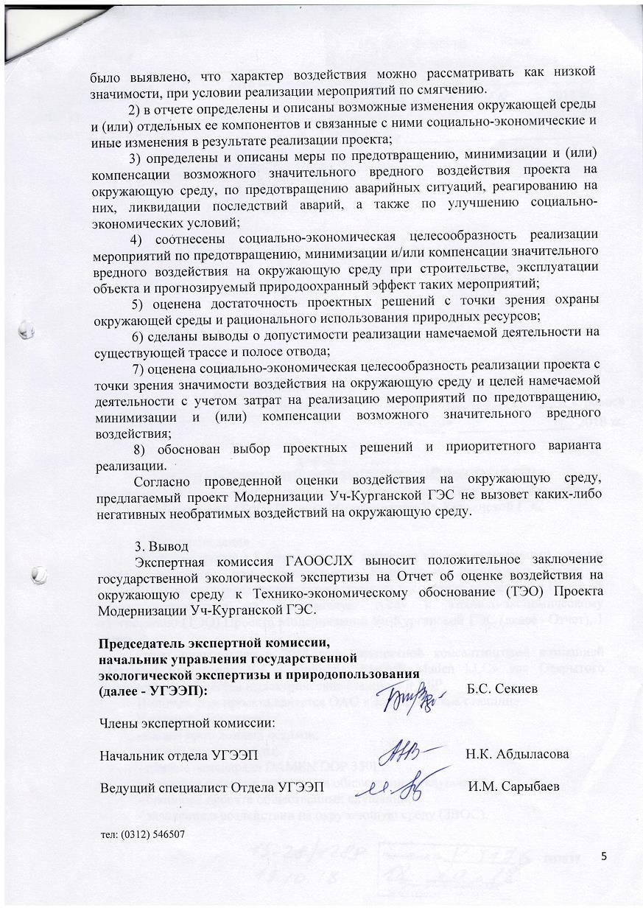

Informal Translation

The State Agency for Environmental Protection and Forestry under the Government of the Kyrgyz Republic

No. 04-8-28/488-E dated 15 October 2018

Approved by Deputy Director
of State Agency for Environmental Protection and Forestry under the Government of the Kyrgyz Republic
/signed/ A.A. Ryspekov date 2018

CONCLUSION
STATE ENVIRONMENTAL EXPERTISE
on the Environmental Impact Assessment Report to the Feasibility Study feasibility study (feasibility study) of the Uch-Kurgan HPP Modernization Project

General information
For consideration by the State Agency for Environmental Protection and Forestry under the Government of the Kyrgyz Republic (hereinafter referred to as the SAEPF), the Environmental Impact Assessment Report for the Feasibility Study (FS) of the Uch-Kurgan HPP Modernization Project (hereinafter referred to as the Report ), 1 book.
The report was prepared in 2018 by the joint consulting company "Tractebel Engineering S.A / Endustriel Elektrik Maden LLC" for the Open Joint Stock Company "Power Plants" and ADB.
The initiator of the project is OJSC "Electric Stations". Attached to the project:
-analysis of bottom sediment samples;
- analysis of water quality;
- data of the DAMEN DOP 350L dredger;
- minutes and list of participants in public hearings;
- a brochure of the draft public hearings;
- statement on the impact on the environment (EIS).

The state ecological expertise was carried out by an expert commission formed by the order of the State Agency for Environmental Protection and Forestry dated 02.26.2018 # 01- 9 / 52.

General part
According to the Report, the Uch-Kurgan HPP is located on the Naryn River in the Jalal- Abad Oblast, approximately 140 km below the Toktogul HPP and at a distance of 500 km from Bishkek.
Uch-Kurgan hydroelectric power station is the first constructed hydroelectric power station on the cascade of the Naryn River and is located 3 km from the town. Shamaldy-Sai. The territory of the industrial site on the hydraulic system is fenced, well greened. The relief of the land plot is flat. The roads are paved.
The industrial site has:
- site of hydraulic structures, including the building of the hydroelectric power station;
- outdoor switchgear (110 kW);
- oil storage
- administrative and production building;
- area for mechanization and transport;
- installation for collecting wastewater (septic tank);
- checkpoints, checkpoint (paramilitary security service).,
According to the Report, an emergency response team (task force), an electrical machine shop, an electrical laboratory, a hydraulic section, electrical equipment - a power plant, and a transport section are working at the HPP.
The dam of the Uch-Kurgan HPP is equipped with four water conduits of hydroelectric generators, eight bottom spillways (bottom water conduits), one surface spillway, two water intake structures for irrigation canals and three gantry cranes.
On the crest of the dam, at a level of 542.00 m, on the left bank side, there is a pumping system designed to supply water to the drinking water supply network of the Shamaldy-Sai village.
The reservoir of the Uch-Kurgan HPP is a reservoir of daily regulation with elevations of 536.5 m and 540.0 m (the permissible operating range of the water level in the upper pool is from 538.7 to 539.5 m), in a narrow and elongated reservoir with a total length of 20 km and width from 200 to 500 m.
The feasibility study and the Report provide for the restoration and modernization of the power plant (construction work and hydro-electromechanical equipment), dams (construction work and hydro-mechanical equipment), high voltage switch and irrigation water intakes, to increase the productivity and safety of the plant, also partial restoration of the reservoir volume and measures to mitigate the environmental impact.
It is envisaged to replace four turbine generating units and all associated equipment of the power plant, including the main transformers, hydromechanical equipment, construction structures of concrete and earth dams will be replaced or repaired, and the capacity of the dam will be restored in case of floods. The existing generator equipment will be completely replaced with a new generator design increasing the capacity to 65 MBA. The two main existing transformers will be replaced with two new 130 MBA step-up transformers.

The 10.5 kV busbars, generator circuit breakers and auxiliary equipment connecting the generators to the main transformer will be replaced. The AC and DC electrical auxiliary systems will be completely replaced and improved. All power and control cables and cable trays must be removed and replaced with new ones. The power plant's main overhead crane and three gantry cranes will be rebuilt.
All mechanical ancillary systems, including water cooling system, drainage equipment, unit drainage system, compressed air systems, oil handling and storage systems, ventilation and air conditioning systems, sewage system, machine shop, fire detection system and firefighting equipment, and water systems will be replaced and improved.
According to the Report, the control and electrical protection system will be completely replaced with digital equipment. Communication equipment will be replaced. To mitigate the risks to the stability of the concrete dam, reinforcement works will be carried out on the right bank dam block, a cement barrier and a tailwater drainage curtain should be added to the dam foundation. Partial restoration of the reservoir volume is envisaged as a result of bottom cleaning operations in the area close to the concrete surface located upstream. Bottom cleaning works will be carried out by the HPP before the start of restoration work.
The project for the modernization of the Uch-Kurgan HPP is considering the possibility of cleaning the reservoir from bottom sediments in the amount of 500,000 m3
The works on cleaning the reservoir will be carried out directly by the Uch-Kurgan HPP.
It is envisaged to deliver the "sediment + water mixture" to a temporary drainage site (quarry), which is an industrial area (wasteland) on the left bank of the Naryn River, 2-3 kilometers from the Uch-Kurgan hydroelectric power station, _ owned by Dostuk Aiyl Okmot and the city Tash-Kumyr, Nooken district Jalal-Abad region.
A large quarry is located in the village of Chuyut-Sai, the embankment is more than 9 m, depth 8-9 m, length 475 m, width 190 m, total volume V = 750,000 m3. The quarry will be used for the disposal of dry sediment transported from the temporary zone. Sediments can be used as a building material (backfilling of trenches, ravines, voids) and other purposes. The distance from the temporary storage area is 15-17 km.
Dredging works will start after the proposed Dredging Works plan is agreed.
According to the Report, the restoration of the facility of each unit will be carried out from March 1 to November 15 (one unit every year from 2021 to 2024), including dismantling the unit, installing a new unit, testing and commissioning.
The mitigation measures foreseen in the EIA Report are in many cases considered high-level measures and should be clarified by the contractor when developing the Detailed Design.
The EIA report includes activities based on identified potential impacts, their characteristics, magnitude, distribution and duration, vulnerable receptors and affected populations.

According to the Report, the proposed modernization works will be located within (service area) of the existing HPP site, and they are relatively distant from '(project influence area) of the existing HPP section, and they are relatively remote from sensitive receptors, except for the reservoir - the Naryn River.
The proposed modernization project will have standard construction impacts: minor noise and dust, possible contamination of surface water, waste generation (scrap metal, domestic and industrial waste).
The proposed bridge rehabilitation will increase noise and vibration, dust, waste generation and create a potential temporary disruption to road traffic.
During the operation of the rehabilitated Uch-Kurgan HPP (after completion of the project), an increase in the design discharge of the power plant (from 760 m3 / s to 880 m3 / s) will change the rules for normal operation of the dam. Typically, the Uch-Kurgan power plant operates at maximum capacity in winter (December to February), and in summer, water discharges are quite low, since the power plant does not produce much energy (no need). With an increase in the design water flow, it can be foreseen that in winter (December, January and February) the power plant will operate at full capacity (880 m3 / s) during peak periods, depending on the availability of water (and depending on the entire functioning of the HPP Cascade river Naryn). This corresponds to an increase in the volume of water releases by about 15%. Even if significant, such an increase in water discharge has already been observed in the downstream over the past 10 years, as shown in the figure below (the figure shows the actual average, maximum and minimum regime of the Naryn River downstream of Uch-Kurgan observed since 2007 - data from an earlier period are not available). As a consequence, the resulting downstream hydrological impact from the potential increase in discharges is within the existing framework.
The report provides an Impact Assessment and Mitigation Measures.
Public hearings on environmental aspects were held on August 7, 2018 in two local authorities - Dostuk Aiyl District and Shamaldy-Sai village, where the public approved the modernization.
After assessing the impacts within the framework of this Report, it is proposed to consider the impact of the project as of low significance, since the predicted impacts are limited to the boundaries of a specific facility, with a small number of them, which are irreversible - in most cases, mitigation measures can be easily developed and included in detailed project.
As a result of the environmental impact assessment:
- according to the Methodology for assessing the significance of the project's impact on the environment, the nature and spatial scale of the possible significant harmful impact of the project on the environment were determined, and it was revealed that the nature of the impact can be considered as of low significance, subject to the implementation of mitigation measures.

- the report identifies and describes possible changes in the environment and (or) its individual components and associated socio-economic and other changes as a result of the project;
- measures are identified and described to prevent, minimize and (or) compensate for the possible significant harmful impact of the project on the environment, to prevent accidents, respond to them, eliminate the consequences of accidents, as well as improve socio-economic conditions;
- the socio-economic feasibility of implementing measures to prevent, minimize and/or compensate for significant harmful effects on the environment during the construction, operation of the facility and the predicted environmental effect of such measures are correlated;
- assessed the sufficiency of design solutions from the point of view of environmental protection and rational use of natural resources;
- conclusions were made about the admissibility of the implementation of the planned activities at existing alignment and right of way;
- the socio-economic feasibility of the project was assessed from the point of view of the significance of the impact on the environment and the goals of the planned activities, taking into account the costs of implementing measures to prevent, minimize and (or) compensate for possible significant harmful effects;
- justified the choice of design solutions and the priority implementation option. According to the conducted environmental impact assessment, the proposed Uch-
Kurgan HPP Modernization project will not cause any negative irreversible impacts on the environment.

Conclusion
The expert commission of the SAEPF issues a positive conclusion of the state ecological expertise on the Environmental Impact Assessment Report for the Feasibility Study (SEO) of the Uch-Kurgan HPP Modernization Project.

The chairman of Department  of State Ecological Expertise and  Natural Resources Management (DSEENRM) | /signed/ | B.S.Sekiev
Commission members: Head of DSEENRM | /signed/ | N.K. Abdylasova
Leading specialist of the Department DSEENRM | /signed/ | I.M.Sarybaev
tel: (0312) 546507

